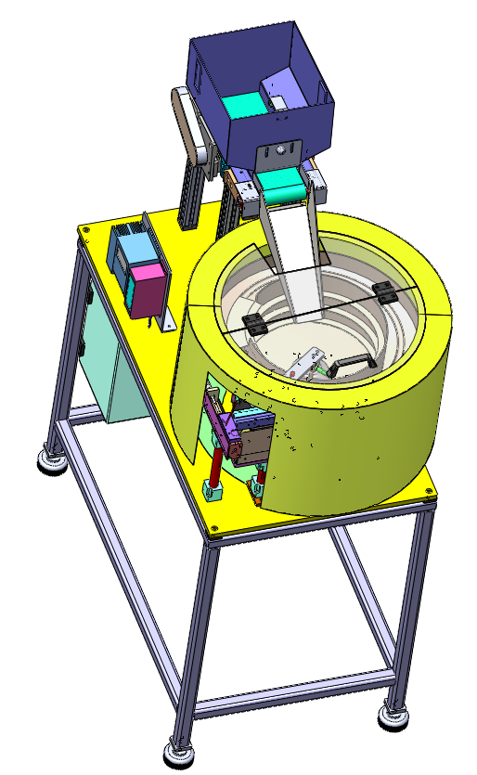
- Type of Quotation
- RFQ Reference No.
  - Project Name
  - Final Customer
  - Country Final Customer
  - Machine Builder
- Type of System
3.1 - 3.3 - Drive, Controller, Current
- Feeding Specification
4.1 & 4.4
- Component Specification
  - & 5.2
- Feeding system - Supporting accessories
- Type of System
- Technical Support with design team
- Options
- Additional Information

No | Description | Shall be filled in by the customer
1 | Type of Quotation: | Rough Budget Price | Budget Price Quote | Official Quotation
2 | RFQ Reference No.
2.1 | Project Name:
2.2 | Final Customer:
2.3 | Country Final Customer:
2.4 | Machine Builder:
3 | Type of System: | Bowl feeder or linear feeder as individual part | Base plate with Bowl & linear feeder | Base plate with Stand, Enclosures & Sub Elec. panel
3.1 | Type of Vibratory Drive | By ELMECH |  | Imported (Sanki, RNA,SINFONIA)
3.2 | Type of Controller | CUH – Chinese make |  | REO – German Make
3.3 | Input Current to the system
4 | Feeding Specification: | Component required orientation | Component loading frequency into the bowl or hopper  (hourly basis) | Feed rate required (parts/min) | Required feeding tracks with Pitch Distance
 |  | 4.1 | 4.2 | 4.3 | 4.4
4.1 | Orientation details  (to be attached with this document) | 2D - drawing | 3D – file of part  (.step) | Photo – jpeg. | Video – MP4 or PDF File
4.4 | Feeding track details  (to be attached with this document)
5 | Component Specification:
5.1 | Nature of the component after feeding should be | Dust free & without damage | Oily / Dry | Scratch proof | Clean
5.2 | Material of the component

Feeding system – Supporting Accessories
Accessories |  | Bulk Hopper feeders – Conveyor type |  |  | Mini Hopper feeders – Vibratory type |  |  | Elevated Hopper feeders |  |  | Gravity hoppers
6.1 | BULK feeders
6.2 | Singling / Invidualizing systems
6.3 | Enclosure for the system | Sound Proof Enclousre (Acoustic foam) |  |  |  | PC sheet Enclosure with Aluminium profile |  | MS Sheet Enclosure
6.4 | Pneumatics used for the system shall have makes | FESTO make |  |  |  | SMC make |  | Any
6.5 | Sensors used for the system shall have makes | OMRON | Banner |  |  | Pepperl+Fuchs |  | Keyence |  | Any
7 | Type of the System | CE Certified system |  |  |  |  | ELMECH Certified System
8 | Technical support
9 | Options | Pick & place unit |  | Blow feeding systems |  |  | Vision based sorting systems |  | Bowl Emptying System
9.1 | Variable models of components Control systems | Variable sorting system |  | Variable Unloading sytsem |  |  | Variable Poke yoke system |  | Variable measurement system
10 | Additional Information:

RFQ-phase:
- This document has to be filled in for each request – this shall not be used for alternative solutions.
- Prices for packing, insurance and transport are not included unless otherwise specified.
- In case of an exact copy of existing supplied bowl feeder of ELMECH, the ELMECH price will be reduced by - 5%.
Definition - Copy of system: same screw, same customer parts, same application, same scope of supply

Project-phase:
- Design Approval (DAP) to ELMECH should be given within 5 workings days to ELMECH. If not, shipment date could be postponed depending on current capacity situation.
- If customer wants a change after the design has been approved, an additional quotation will be made and the customer must modify his order accordingly.
This may result in a higher price and additionally, we will have to ask for a handling fee for administrative efforts.

