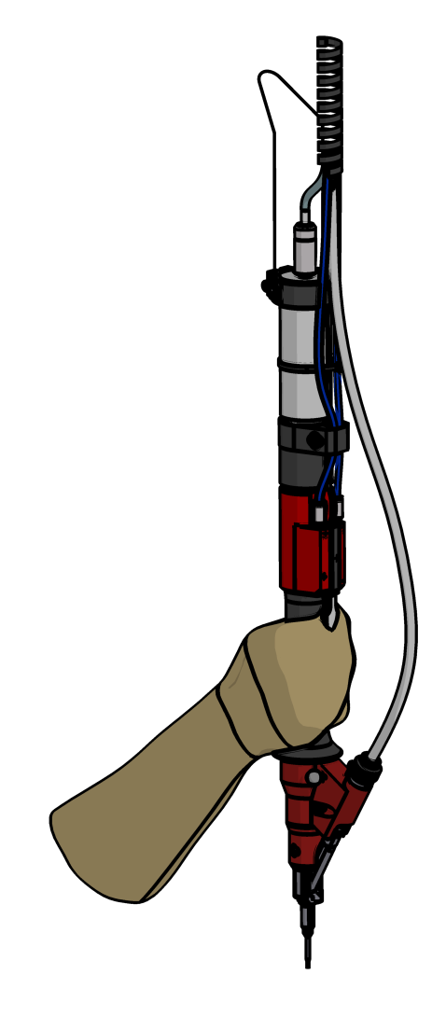
- Type of Quotation
- RFQ Reference No.
  - Project Name
  - Final Customer
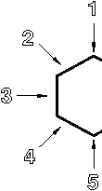
  - Country Final Customer
  - Machine Tool Builder
- Reference System
3.1 - 3.4Type of Drive and Controller
- Specification (Work Direction)
- Drawings Attached(as required)
- System Mounted on
- Type of System and Amount
- Controller requirement
- Options
- Additional Information

No | Description | Shall be filled in by the customer
1 | Type of Quotation: | Rough Budget Price |  |  | Budget Price Quote |  | Official Quotation
2 | RFQ Reference No.
2.1 | Project Name:
2.2 | Final Customer:
2.3 | Country Final Customer:
2.4 | Machine Tool Builder:
3 | Reference-System: | Copyof Machine: |  |  | Spare Parts for Machine: |  | Modification of Machine:
3.1 | Type of drive and drive controller: | By ELMECH |  |  | By Customer |  | Brand & Type (completename)
3.2 | Electric
3.3 | Pneumatic
3.4 | + Torque transducer
4 | Specification: | Torque +/- tolerance  (Nm) |  |  | Working direction (1-5) |  | Cycle time in Sec. (Start – home pos.) |  |  | Length of required stroke
5 | Drawings attached:  in the way they shall be used | 2D – screw drawing  (metrical) |  |  | 3D – file of part  (.step) |  | Tightening mask |  |  | Clamping device
Scopeof Supply (preferred)
6 | System mounted on: | Axis System |  |  | Robot  max. weight |  | Stationary |  |  | Handling device
 |  | XY |  | XYZ |  | kg
7 | Type of System:  (n=amount) | n | Screw drivingunit |  | n | Feed unit |  |  | n | Control unit
8 | Interface between Controller and Master | Digital I/O |  |  | BUS systems (Profinet / Ethercat / etc.)
9 | Options: | Hopper |  |  | Spare parts |  |  | Manual  (foreignlanguage)
10 | Additional Information:

RFQ-phase:
- This document has to be filled in for each request – this shall not be used for alternative solutions.
- Prices for packing, insurance and transport are not included unless otherwise specified.
- In case of an exact copy of existing machine, the ELMECH price will be reduced by - 5%.
Definition - Copy of machine: same screw, same customer parts, same application, same scope of supply
Project-phase:
- Design Approval (DAP) to ELMECH should be given within 5 workings days to ELMECH. If not, shipment date could be postponed depending on current capacity situation.
- If customer wants a change after the design has been approved, an additional quotation will be made and the customer must modify his order accordingly.
This may result in a higher price and additionally, we will have to ask for a handling fee for administrative efforts.

